Getting started
The Australian Government has created the National Disability Insurance Scheme (NDIS) to help people with disabilities to live a full and meaningful life. This might mean being able to live independently, learn, work or be more involved in their community.
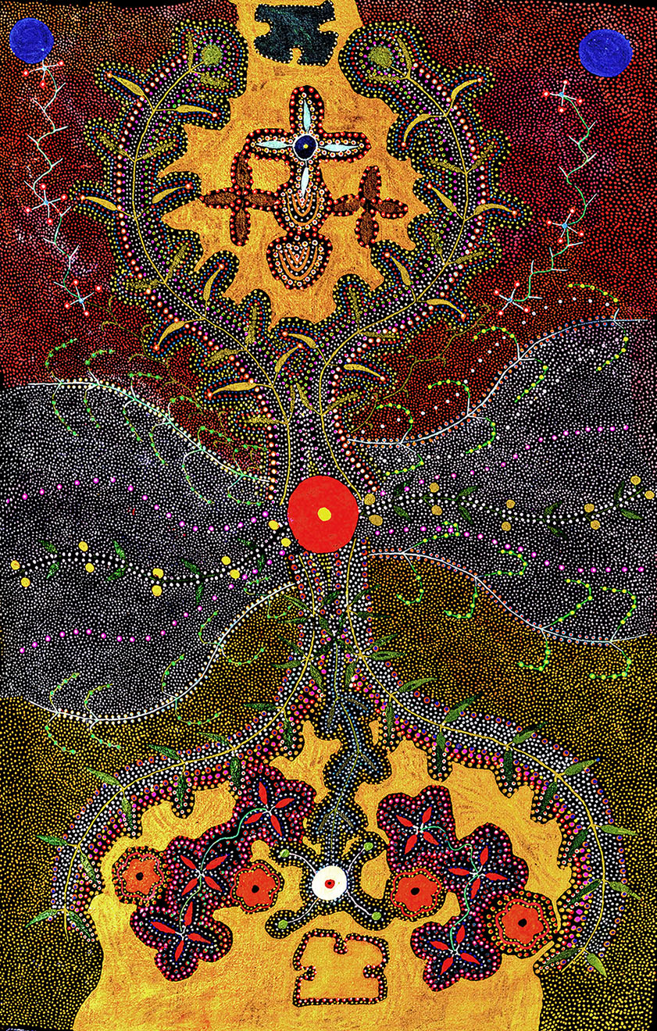

Acknowledgement of Country
The National Disability Insurance Agency (NDIA) acknowledges the Traditional Owners and Custodians throughout Australia.
The NDIA would like to honour their continuing connection to land, water and seas. The NDIA pays its respects to their Elders - past, present and emerging.

Artwork story
This painting is by Aboriginal artist, Carol Beasley who is from the Barkly region, an area bigger than the entire state of Victoria – Tennant Creek is the main town.
Carol was born in Hatches Creek and now lives in Epenarra. Her first language is Alyawarr - one of 16 Aboriginal languages spoken in the region.
When Carol was young, she travelled a lot around her Country to places like Elkedra, Epenarra, Hatches Creek, Canteen Creek and Ali Curung. Her mother died when she was very young. After that, her Aunty raised her on Elkedra cattle station. She also taught Carol to paint.
Painting is part of Carol’s culture. It shows her connection to Country and the stories of her people. Carol likes to paint stories about bush tucker. She paints very slowly and carefully. She also likes to sing stories with families.
Carol’s painting here shows bush tucker from the Epenarra region – bush tomatoes, bush banana vines and leaves, bush beans and plants that grow near water. It also tells the story of two women collecting bush tucker.
Artwork credit: Bush Tucker – Epenarra © Carol Beasley 2018
Carol’s painting contains traditional knowledge of the Wetengerr community. It has been shared with the consent of the Wetengerr community custodians.

Let’s talk about disability
The NDIS is for people under the age of 65 with permanent and significant disability.
Permanent means the disability will not go away.
Significant means the disability affects how you live every day.
A disability is a physical (body) or mental (mind) condition that limits someone’s movements, senses or ability to take part in activities.
This can make it hard to do things like walking (mobility), talking or listening (communication), or getting involved in the community (participation).

How the NDIS could help you
If you have a disability or are caring for someone who has a disability, the NDIS could provide the support you need.
The NDIS provides money to people under 65 who have a permanent and significant disability to pay for services, equipment and
supports so they can live their best life. It also supports their families and other people who care for them.
The NDIS can also help with getting access to services.
You should think and talk about what kind of things, including services, you need to live a better life with your disability. It’s a good idea to talk to your family, friends and other people in your community.
There are different people in your community who work for the NDIS:
- Local Area Coordinator (or LAC)
- Community Connector
- Early Childhood Early Intervention partner.
A Local Area Coordinator or Community Connector can help you find activities in the community and support services.
Early Childhood Early Intervention (or ECEI partner) helps children with disability or developmental delay under the age of 7.

How does it work?

Step 1: Find out if the NDIS can help you
If you think you may be eligible for the NDIS, you can talk to:
- an NDIS representative by calling 1800 800 110
- someone at your local Aboriginal Health Service or community health clinic.
You will be asked some questions about your life and your disability. You may also need to provide identification and reports from doctors or other health workers.
The NDIS will then tell you if you can get an NDIS plan.

Step 2: Making a plan
If you are eligible for an NDIS plan, you will have a meeting to talk about how you live now and what your plans are for the future.
Together with an NDIS representative, you will make a plan that outlines your goals and the support, services and equipment you need to meet them.
Your plan will be sent to the NDIS and you will keep a copy.
The NDIS will tell you if it agrees with your plan and how much money you can have to pay for it.

Step 3: Using your plan
You can use NDIS money to pay for the support, services and equipment you need for your disability.
You might already have family, friends and service providers working with you. You can choose to keep getting support from the same people or you can make changes.
You can talk to your Local Area Coordinator about choosing service providers.
You can talk to an NDIS representative at any time about your plan or the NDIS. You can also bring someone with you to your meetings.

Step 4: Review your plan
About a year after you create your first plan, you will have a meeting to check how your plan is going. This is so you can change your goals or the help you receive.
The amount of money you can use for your plan might change when you make a new plan.

More information
You can get more information by talking to an NDIS representative, or the NDIS.
You can also talk to someone at your local Aboriginal Health Service, community health clinic or another health professional in your community.

For more information, please contact:
- 1800 800 110
- NDIS.gov.au
- enquiries@ndis.gov.au
- Find us on Facebook/NDISAus
- Follow us on Twitter @NDIS

For people who are Deaf or hard of hearing:
- TTY: 1800 555 677
- Speak and listen: 1800 555 727

Indigenous Interpreting Service
The Local Area Coordinator can arrange an Indigenous interpreter if English is not your first language.

Other Supports
Aboriginal and Torres Strait Islander peoples aged 50 years and over may be eligible for support through the My Aged Care program. For more information visit myagedcare.gov.au

