How to start NDIS

Easy Read
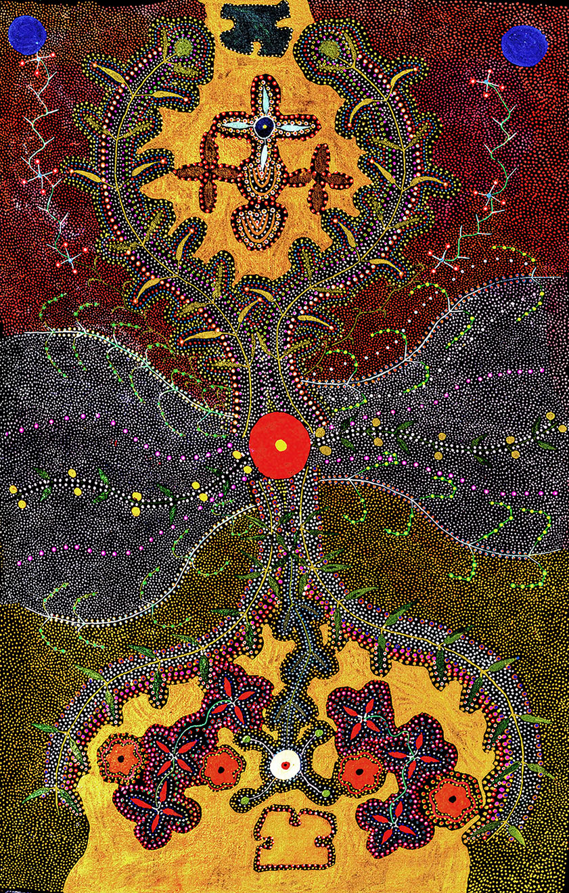

Acknowledgement of Country
The National Disability Insurance Agency (NDIA) acknowledges the Traditional Owners and Custodians throughout Australia.
The NDIA would like to honour their continuing connection to land, water and seas. The NDIA pays its respects to their Elders - past, present and emerging

What is Easy Read?
Easy Read is another way to help you understand.
This book has some hard words.
The first time we write a hard word it is in blue and we write what the hard word means.
We have other Easy Read books and factsheets that you can download on our website (ndis.gov.au).

Do you need help with this booklet?
You can get someone to work with you to:
- read this book
- know what this book is about
- find more information.

Let’s talk about disability
A disability is something in the body or mind that can make it hard for a person to do everyday things.
People with disability can find it hard to:
- move and get around
- learn
- talk
- eat
- see
- hear
- understand things
People with disability want the same things as everyone else.
They want to:
- learn
- get a job
- have fun.

How the NDIS could help you
The National Disability Insurance Scheme is called the NDIS.
The NDIS helps people with disability, their family, carers and the community.
The NDIS helps people under the age of 65 with permanent and significant disability get care and supports.
- Permanent means the disability will not go away.
- Significant means the disability affects how you live every day.

The NDIS will pay for reasonable and necessary supports that a person needs to live and enjoy their life.
- Reasonable means something that is fair
- Necessary means something a person must have
To get services and support, you need to join the NDIS.

Should you apply to join the NDIS?

Talk to people who know how the NDIS works
There are different people in your community who work for the NDIS:
- Local Area Coordinator
- Community Connector
- Early Childhood Early Intervention partners.
Local Area Coordinators (or LAC) and Community Connectors can help you find local activities and support services.
If you need more support, your Local Area Coordinators can work with you to make your NDIS plan. They can explain how the NDIS can make your life even better.
Early Childhood Early Intervention (or ECEI partners) help children with disability or age-related delay, who are aged under 7.
When you talk to someone who works for the NDIS, they will find out things about you such as:
- your name
- your age.
You might need to bring things:
- to show who you are
- from a doctor to explain your disability.
You can also talk to people who work for community health services.

Make an NDIS plan
If the NDIS agrees you need care and support, you will meet with the NDIS to make a plan.
People with an NDIS plan will get supports and services they need.
An NDIS plan can help pay for:
- equipment you need
- support you need at home
- support to go out.
The NDIS will pay for different supports for different people. This is because different people will want different things
When you meet with the NDIS you will talk about:
- supports and services you need
- the types of help you get now how you do things now
- what you are good at
- what is hard for you.
Your plan will say:
- what you want to do (your goals)
- what kind of help you need to do the things you want (your supports).
Your plan will help you to do everyday things like:
- go to the shops
- cook meals
- drive to work
- go to community activities
- go onto Country
- get a job
- try new things
Think about what you need.
You can talk about what should be in your plan with:
- family
- friends.
You can also talk to:
- your local Aboriginal health service
- community health clinic.
When your plan is done, you will get a copy.
The NDIS will pay for services and support in your plan. The NDIS can make it easier to do the things you want to do.

Use your plan
If the NDIS says OK to your plan, you can choose who will give you the help you have asked for.
It could be:
- someone who helps you now
- someone new.
The NDIS will pay for services, support and equipment in your plan.
You can talk to a Local Area Coordinator, Early Childhood Early Intervention partner or Community Connector if you have any questions.

Check your plan
After about 1 year, you will have another meeting to check your plan.

This is so you can change things if you want to.

This can be about your goals or about the help you need.

If your plan changes, there may be a change to the amount of money you can use.

More Information
You can talk to an NDIS representative, or the NDIS, at any time about your plan. You can also bring someone to your meetings.

For more information, please contact:
- 1800 800 110
- NDIS.gov.au
- enquiries@ndis.gov.au
- Find us on Facebook/NDISAus
- Follow us on Twitter @NDIS

For people who are Deaf or hard of hearing:
- TTY: 1800 555 677
- Speak and listen: 1800 555 727

Indigenous Interpreting Service
The Local Area Coordinator can arrange an Indigenous interpreter if English is not your first language.

Other Supports
Aboriginal and Torres Strait Islander peoples aged 50 years and over may be eligible for support through the My Aged Care program. For more information visit myagedcare.gov.au

